**Deliverable 2**

Report Date: 2023.10.19

**1. Work in Progress:**

Our team has made significant progress in the development of our project---Bubble Tea house Management System.

The WPF interfaces are almost finished and just require minor polishing.

Key functionalities implemented by this stage:

1. Process Order:

The "Process Order" functionality allows customers to select their desired bubble tea items from the menu.

Customers can customize their order by choosing the type of tea, flavor, sweetness level, and ice quantity.

Once the order is customized, customers can add it to their shopping cart for review.

2. Shopping Cart:

The "Shopping Cart" functionality displays a summary of the items added to the cart during the order process.

Customers can view the details of each item in the cart, including the type of tea, flavor, sweetness, ice choice, and quantity.

Customers can update their order by changing the quantity of items or making adjustments to customizations.

The system dynamically recalculates the total cost of the order based on any updates made in the cart.

Customers can remove items from the cart if they change their minds or no longer want a particular item.

The functionality ensures that the shopping cart accurately reflects the customer's order and its total cost.

Screenshots of WPF interfaces and functionalities in action:

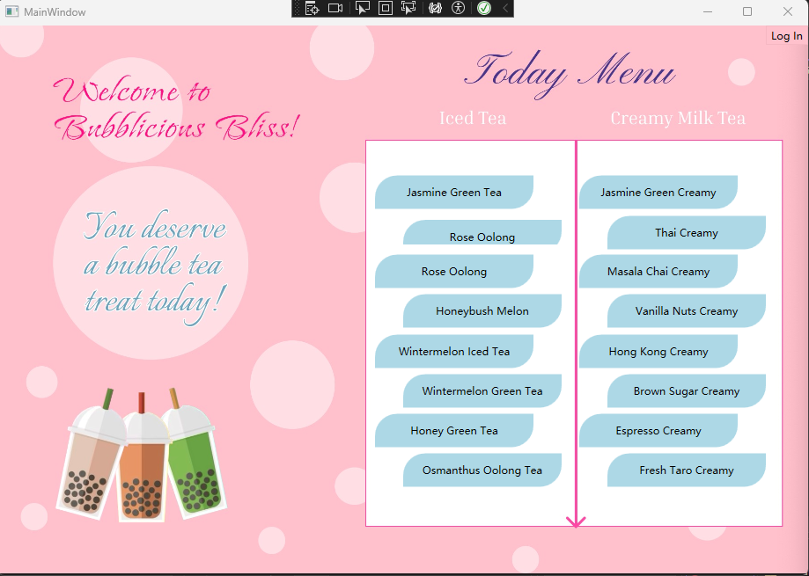

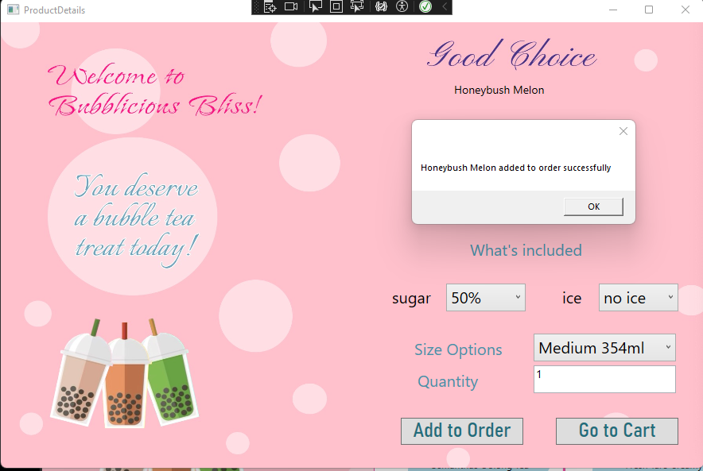



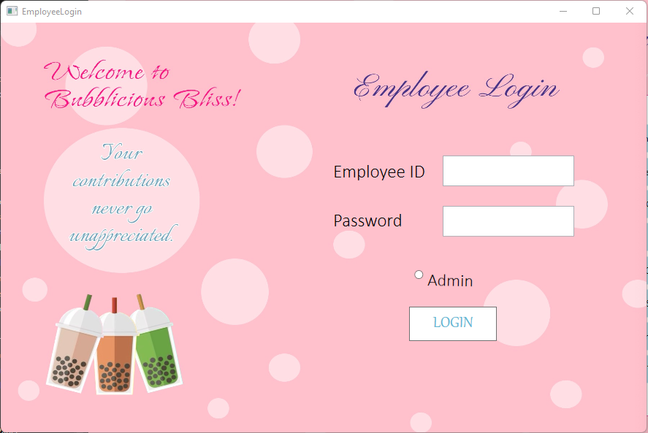

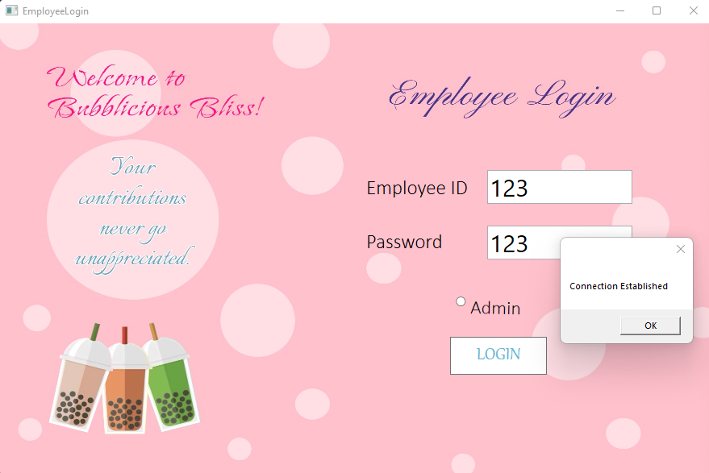

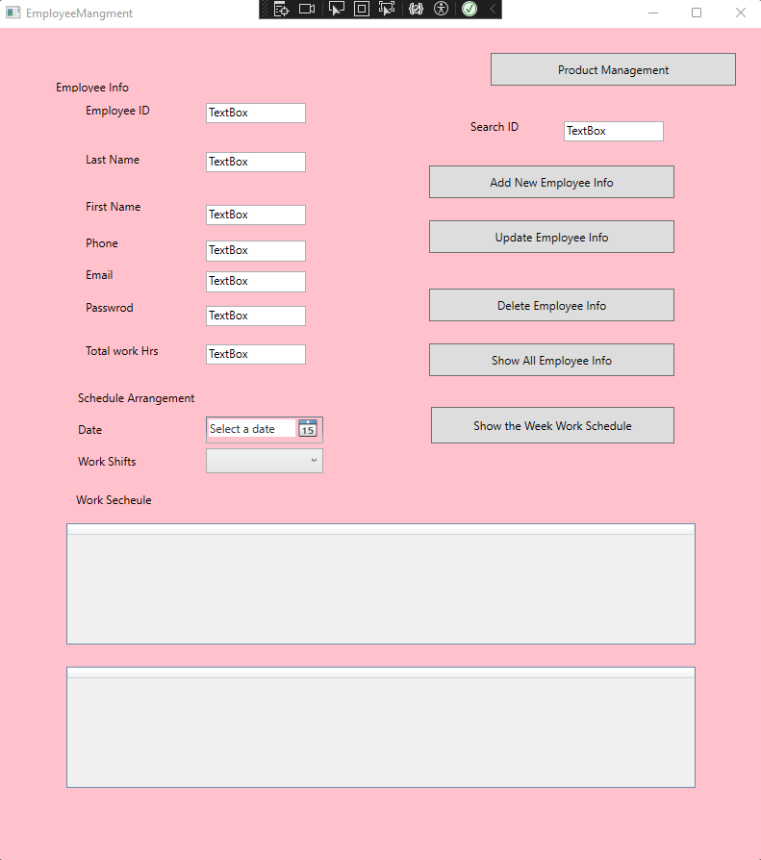

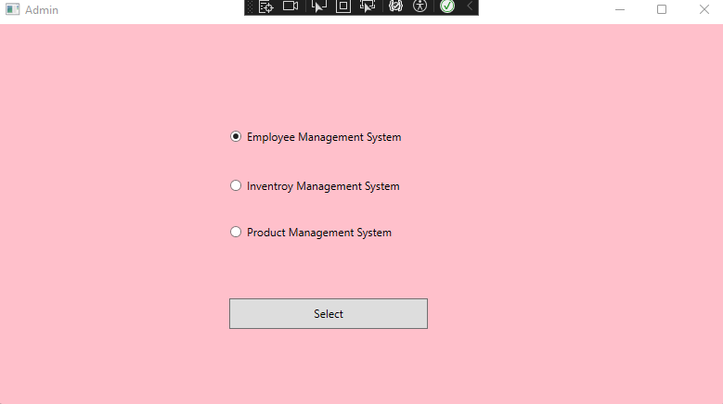

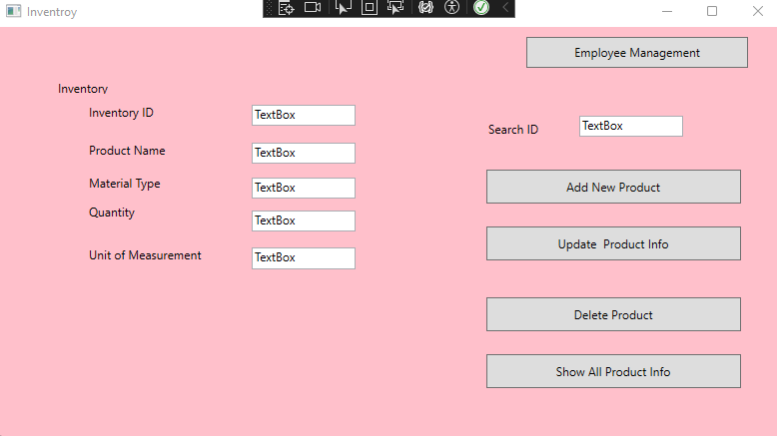

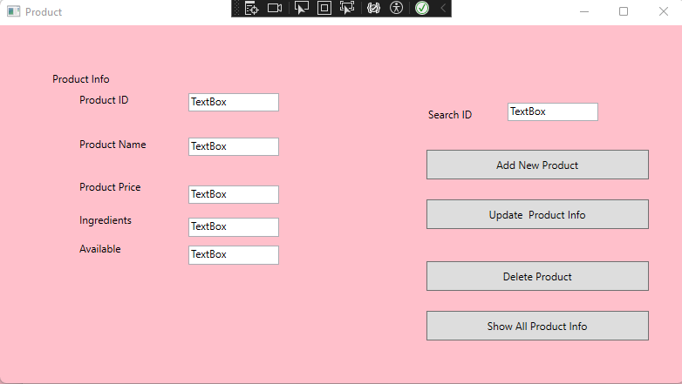

Screenshot of employee management table:

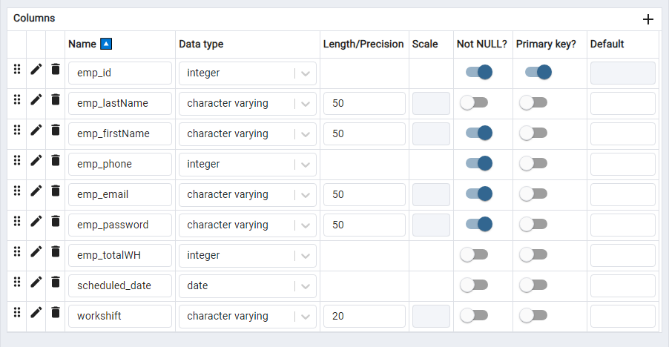

2. Tools Finalized:

Back-end framework: C# with WPF .NetFramework 4.7.2

Database: PostgreSQL

Other Tools:

Front-end framework: Figma for designing the user interface.

3. Plan for the Next 4 Weeks:

Each team should outline their working plan for the next four weeks, including how they will divide the work among team members and distribute it across the weeks.

Week 5:

Develop the back-end server-side logic and API using C#.

Integrate the back end with the front-end interface.

Week 6:

Implement user authentication and authorization functionality.

Set up data storage and retrieval methods, including integration with PostgreSQL.

Week 7:

Perform integration testing of the entire system, including both front-end and back-end components.

Address any issues or bugs discovered during testing.

Week 8:

Perform a final round of testing in a production-like environment.

Deploy the teahouse management system to production, making it accessible to users.

This plan ensures that we stay on track and complete the project in a timely manner.